**Java Evidence Question**

1. Create three tables with the following columns-
2. Product

|  |  |  |
| --- | --- | --- |
| ProductId | Int | (Pk) |
| ProductName | varchar |  |
| Stock | Int |  |
| Price | double |  |

1. Sales

|  |  |  |
| --- | --- | --- |
| SalesNo | int | (Pk) |
| CustomerId | int | (Fk) |
| ProductId | Int | (Fk) |
| Quentity | Int |  |
| Price | double |  |

1. Customer

|  |  |  |
| --- | --- | --- |
| CustomerId | Int | (Pk) |
| CustomerName | varchar |  |
| Address | varchar |  |

1. Insert five row of data for product and customer table.
2. Create a from like following -

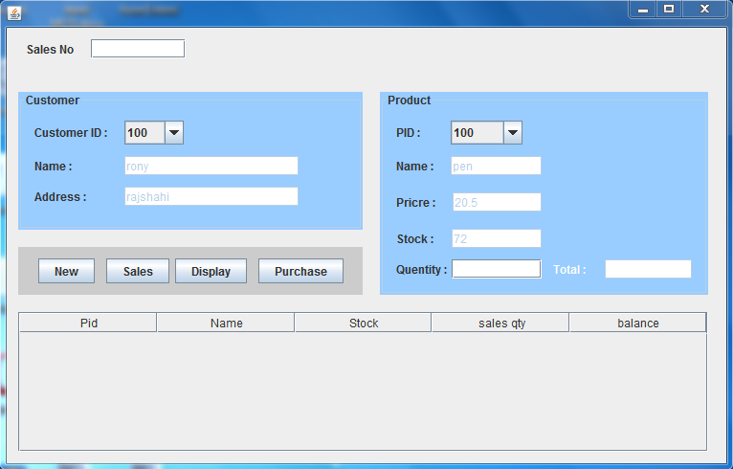

1. CustomerID and Product ID will be combo and other will be text field.
2. New button will generate an unique number for Salse No text field.
3. Sales button will save data to sales table and deduct quantity from stock.
4. Purchase button will add quantity to stock.
5. Display button will display Product ID, Product Name, Stock, Total Sales of a product, Balance.